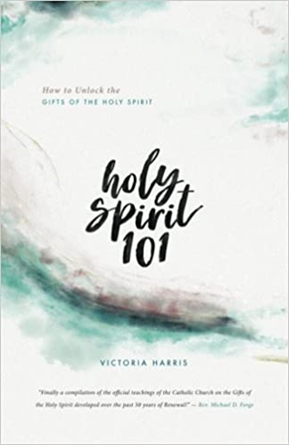

Join us to prepare for Pentecost by attending Holy Spirit 101. You will discover how to listen, discern and yield to the Holy Spirit for the building up of the Church. You will learn what the Catholic Church teaches about the gifts of the Holy Spirit, the 10 steps of Intercessory Prayer, the introduction to the Gifts of Healing, Miracles, Prophecy, Words of Knowledge and Wisdom. By attending you will know how to incorporate the gifts of the Holy Spirit into our Parish Community. Anyone who is 14+ is invited to attend. Recommend the book Holy Spirit 101 by Victoria Harris sold on Amazon and book stores. We will meet in Garden View Room, Monday nights from April 25th - June 13th from 7 to 8:30pm except Memorial Day. You are welcome to start on the second session if you cannot make the first one. Contact Mary Joan Sutton 715-441-9699 with questions.

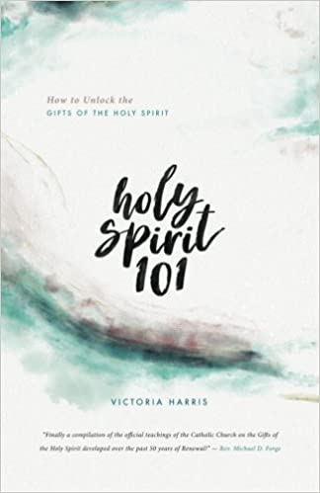

Join us to prepare for Pentecost by attending Holy Spirit 101. You will discover how to listen, discern and yield to the Holy Spirit for the building up of the Church. You will learn what the Catholic Church teaches about the gifts of the Holy Spirit, the 10 steps of Intercessory Prayer, the introduction to the Gifts of Healing, Miracles, Prophecy, Words of Knowledge and Wisdom. By attending you will know how to incorporate the gifts of the Holy Spirit into our Parish Community. Anyone who is 14+ is invited to attend. Recommend the book Holy Spirit 101 by Victoria Harris sold on Amazon and book stores. We will meet in Garden View Room, Monday nights from April 25th - June 13th from 7 to 8:30pm except Memorial Day. You are welcome to start on the second session if you are unable to make the first one. Contact Mary Joan Sutton 715-441-9699 with questions.

